1. Female patients who have started HPV vaccination.
2. All patients who have started HPV vaccination.
3. Black people who have started HPV vaccination.
4. Asian people who have started HPV vaccination.
5. White people who have started HPV vaccination.
6. Male patients who have started HPV vaccination.
7. Hispanic people who have started HPV vaccination.
8. Non-Hispanic people who have started HPV vaccination.

**Figure A**. The age distributions of HPV vaccinated patients among different genders, races, and ethnicities groups.

**Figure B**. The HPV vaccine initialized rate on the Long Island among 9- to 13-year-old kids. The rate here was calculated by the number of kids who already initialized the HPV vaccination divided by the number of kids either receive the HPV vaccination or Tdap vaccination.

1. Gender Disparities of the Rate in Kids (9-13).
2. Rate among Nassau Kids Gender Disparities (9-13).
3. Rate among Suffolk Residents Gender Disparities (9-13).
4. Rate among Kids in Different Races Group (9-13).

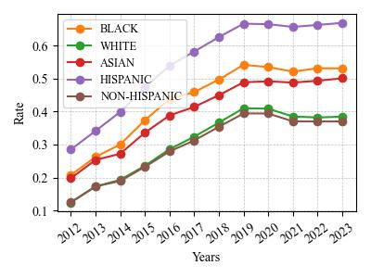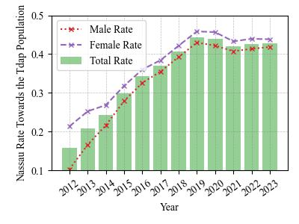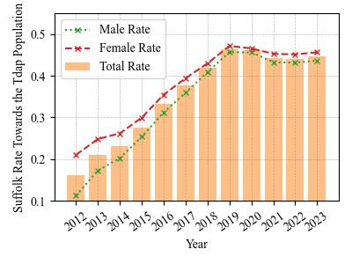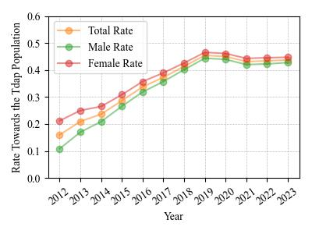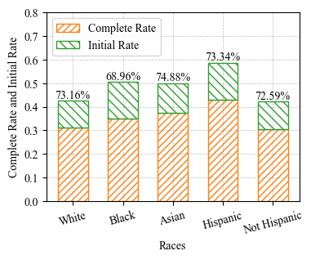

**Figure C.** The completeness of the HPV vaccinated individuals on the Long Island, New York State, 2012-2023. The figures are generated according to the CDC HPV vaccination guidelines.

1. The Nested Pie Chart shows the HPV Vaccination Patients Doses Schedule and Completeness Portion.

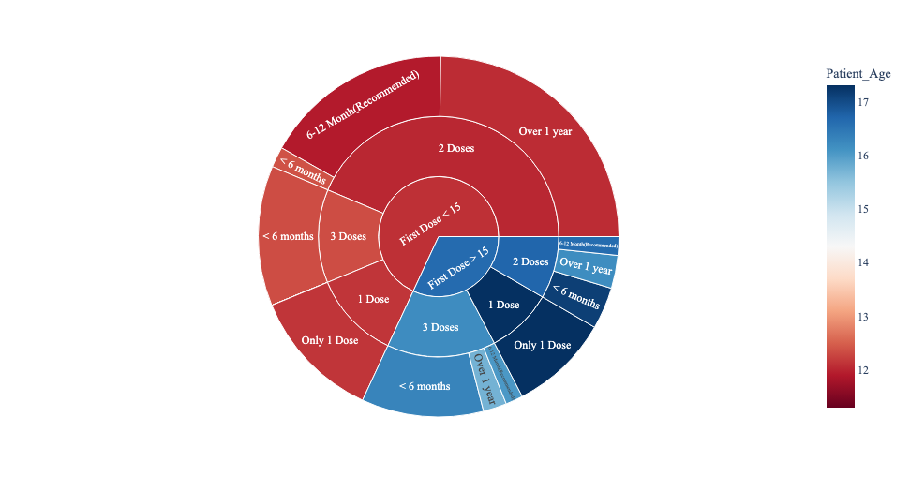

1. Gender Disparity of Completeness
2. Race Disparity of Completeness

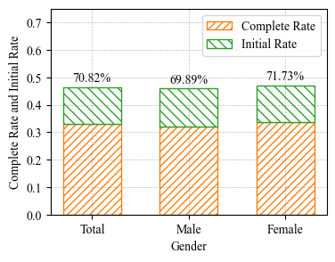

|  |  |  |  |  |  |  |  |  |  |  |  |  |  |  |
| --- | --- | --- | --- | --- | --- | --- | --- | --- | --- | --- | --- | --- | --- | --- |
| **Table A.** Summary of Aggregation Information of HPV Vaccination Patients on the Long Island. (The patients from the entire NYSIIS database) 1 | | | | | | | | | | | | | |  |
|  |  | 2012 | 2013 | 2014 | 2015 | 2016 | 2017 | 2018 | 2019 | 2020 | 2021 | 2022 | 2023 |  |
| Gender | Male | 20574 | 38493 | 56711 | 77367 | 99946 | 120951 | 142650 | 163788 | 179135 | 193555 | 209654 | 225007 |  |
| Female | 55221 | 70823 | 86802 | 106035 | 126958 | 146873 | 166948 | 187044 | 202339 | 216664 | 232859 | 248334 |  |
| Age | 9-142 | 16458 | 23004 | 28215 | 36383 | 44374 | 49557 | 54729 | 58983 | 56735 | 52808 | 51848 | 51522 |  |
| 14-26 | 59331 | 86296 | 115183 | 146644 | 181202 | 214563 | 246876 | 277885 | 302238 | 322171 | 338127 | 348376 |  |
| >=26 | 398208 | 364699 | 330602 | 290973 | 248423 | 209879(1)4 | 172395 | 137130(3) | 115027(1) | 99021(3) | 84023(3) | 74101(6) |  |
| Race and Ethnic | White | 32635 | 49774 | 66838 | 86873 | 109218 | 130939 | 152995 | 174070 | 190051 | 203714 | 218956 | 233244 |  |
| Black | 6643 | 9529 | 12635 | 16727 | 21117 | 25031 | 28954 | 32860 | 35569 | 38436 | 41532 | 44677 |  |
| Asian | 3990 | 5803 | 7830 | 10642 | 13637 | 16675 | 20017 | 23285 | 25957 | 28451 | 31613 | 34801 |  |
| Hispanic | 14329 | 21043 | 29631 | 39846 | 51594 | 61855 | 72568 | 84262 | 92393 | 101611 | 112155 | 122192 |  |
| Non-Hispanic | 38598 | 58515 | 78026 | 101732 | 127471 | 152483 | 177657 | 201188 | 219371 | 234853 | 252642 | 269436 |  |
| Total |  | 75954 | 109540 | 143808 | 183751 | 227304 | 268268 | 310072 | 351339 | 381998 | 410773 | 443121 | 473995 |  |

1. The absolute numbers here represent the number of individuals who in the specific group already initialized the HPV vaccination doses series.
2. Kids with age 9- to 13-year-old are the targeted population to study in this paper.
3. HPV vaccination is not recommended for everyone older than age 26 years.
4. The number in the bracket shows the newly added patients who initialized the HPV vaccination at that year.